IFT 401 Information Technology Capstone I

Milestone 4: System Design

Matthew Buchan, Ricardo Garcia, Michaela Pawlowski

Prof. Damien Doheny, Dr. Renu Balyan

Table of Contents

PROJECT CONCEPT 3

USER INTERFACE 4

INFRASTRUCTURE AND INFORMATION ARCHITECTURE 7

# **PROJECT CONCEPT**

The classroom team at the Engineering Technical Services (ETS) is a group that is tasked with reviewing the end-user license agreements (EULA) for the software ASU offers to faculty, staff, and students. A EULA is a legal document where the contingencies of a software’s use are found. Each semester, ETS has over 50 new software packages that are deployed. Each software package includes a EULA that the classroom team must review to maintain compliance, which creates hundreds of hours of work across each semester. Since this is a recurring task that occurs at the beginning of each semester, the classroom team’s time can be saved by automating the process. Currently, ETS’ intern team is exploring solutions using natural language processing (NLP), the act of computationally analyzing language for appropriate meaning. After the EULA is analyzed and the agreements have been appropriately parsed, that information will be stored in a database that ETS staff members can access. A web interface will be developed for the source document importation. Later,

# **USER INTERFACE**

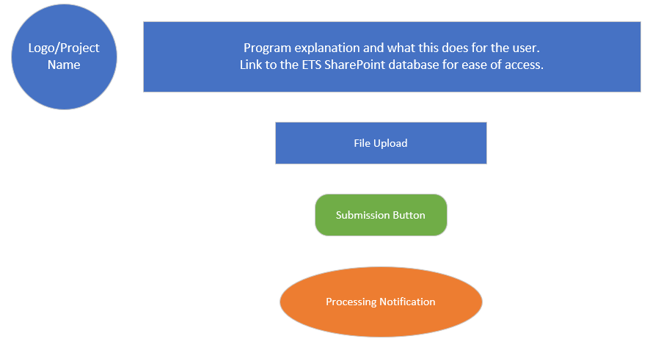The user interface will be comprised of a web graphical user interface (GUI). Users will only interact with the webpages in the front-end environment while the back-end performs the input document processing. The main page will include a description of the system as well as the user input requirements. Please refer to Figure 1 below:

Figure 1: Home Page Structure

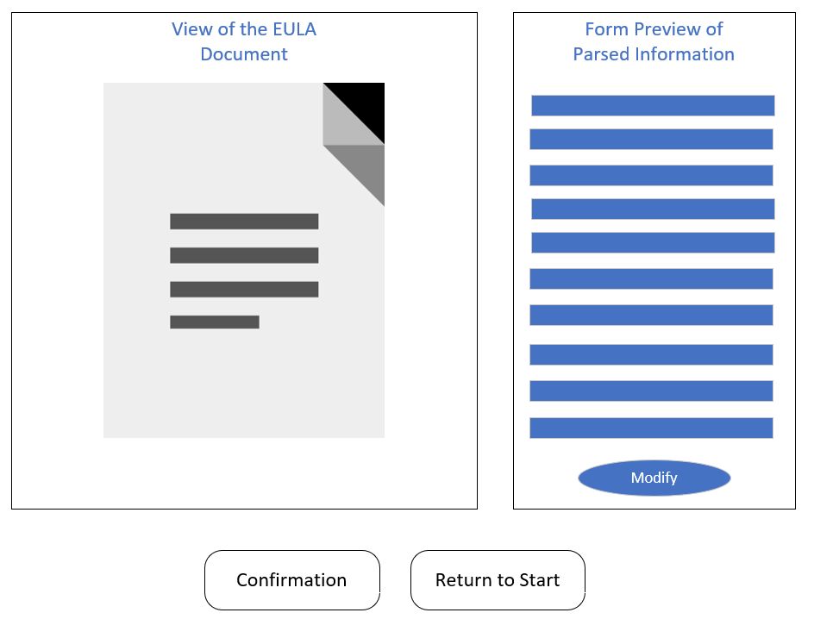Once the user uploads a file from their personal device, they will finalize the submission, allowing the system to process the document. Once the document is processed, the user will be redirected to a parse preview webpage where the extracted information will be displayed. The displayed information will follow the same structure as ETS’ SharePoint database. Next to the parsed information will be a preview of the source document. Users will be allowed to modify the extracted information to make changes or fill in missing fields that were not found by the program. Afterwards, the user will have the option to send the output to SharePoint or return to the home page to process a new document. Please refer to Figure 2 below for the parse preview page structure:

Figure 2: Parse Preview Page Structure

Additionally, if the user sends the extracted information directly to SharePoint, a prompt will appear giving the user the option to access the database or begin processing a new input document. If the user chooses to view the database, they will land on a page similar to the one shown in Figure 3:

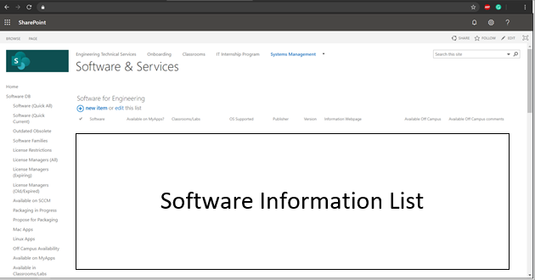

Figure 3: SharePoint Database Mega List

ETS staff members with administrative access will see a complete software list with all field details. Students can also access ETS’ SharePoint database; however, their view is limited and does not provide as much information

If the information

# **INFRASTRUCTURE AND INFORMATION ARCHITECTURE**

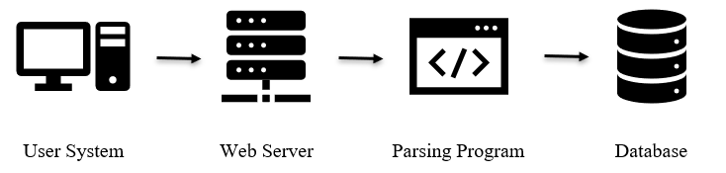

Figure 4: Required Infrastructure

Minimal data components will be required of the user. In this case, only a source document is required. Please reference Figure 5 below:

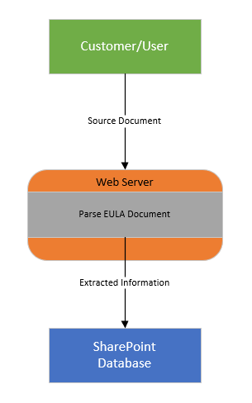

Figure 5: Required Data Components

After the program processes the information held in the source document, the user will be directed to a preview page where they can opt to modify the extracted information if they wish. The structure of the user’s interaction can be found in Figure 6 below:

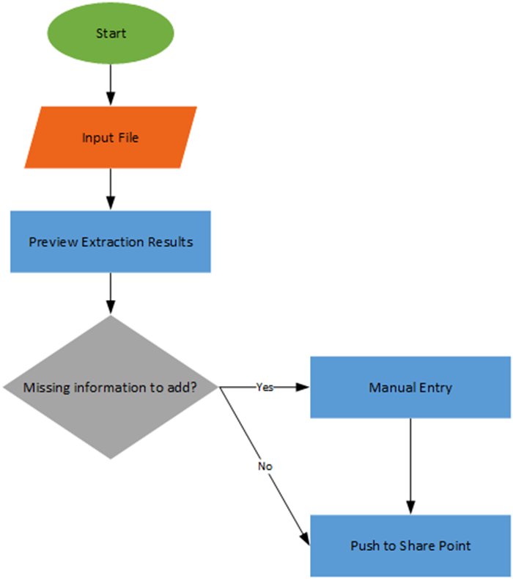

Figure 6: User Interaction Diagram